Dear <Username>,

You are about to login using VeriLeap verification software. Please replace one of your password gesture with our One-Time-Password (OTP) gesture as attached to the email when you are prompted to input your gestures.

If you did not attempt to login, your account details could be compromised as someone could be attempting to break into your account. Please login and change your password (gestures).

Step 1: Place your Leap Motion device in this orientation

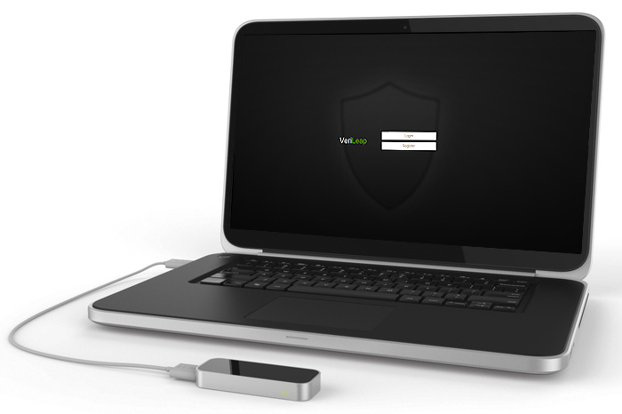

Step 2: Place your hand as shown over the device

-VeriLeap